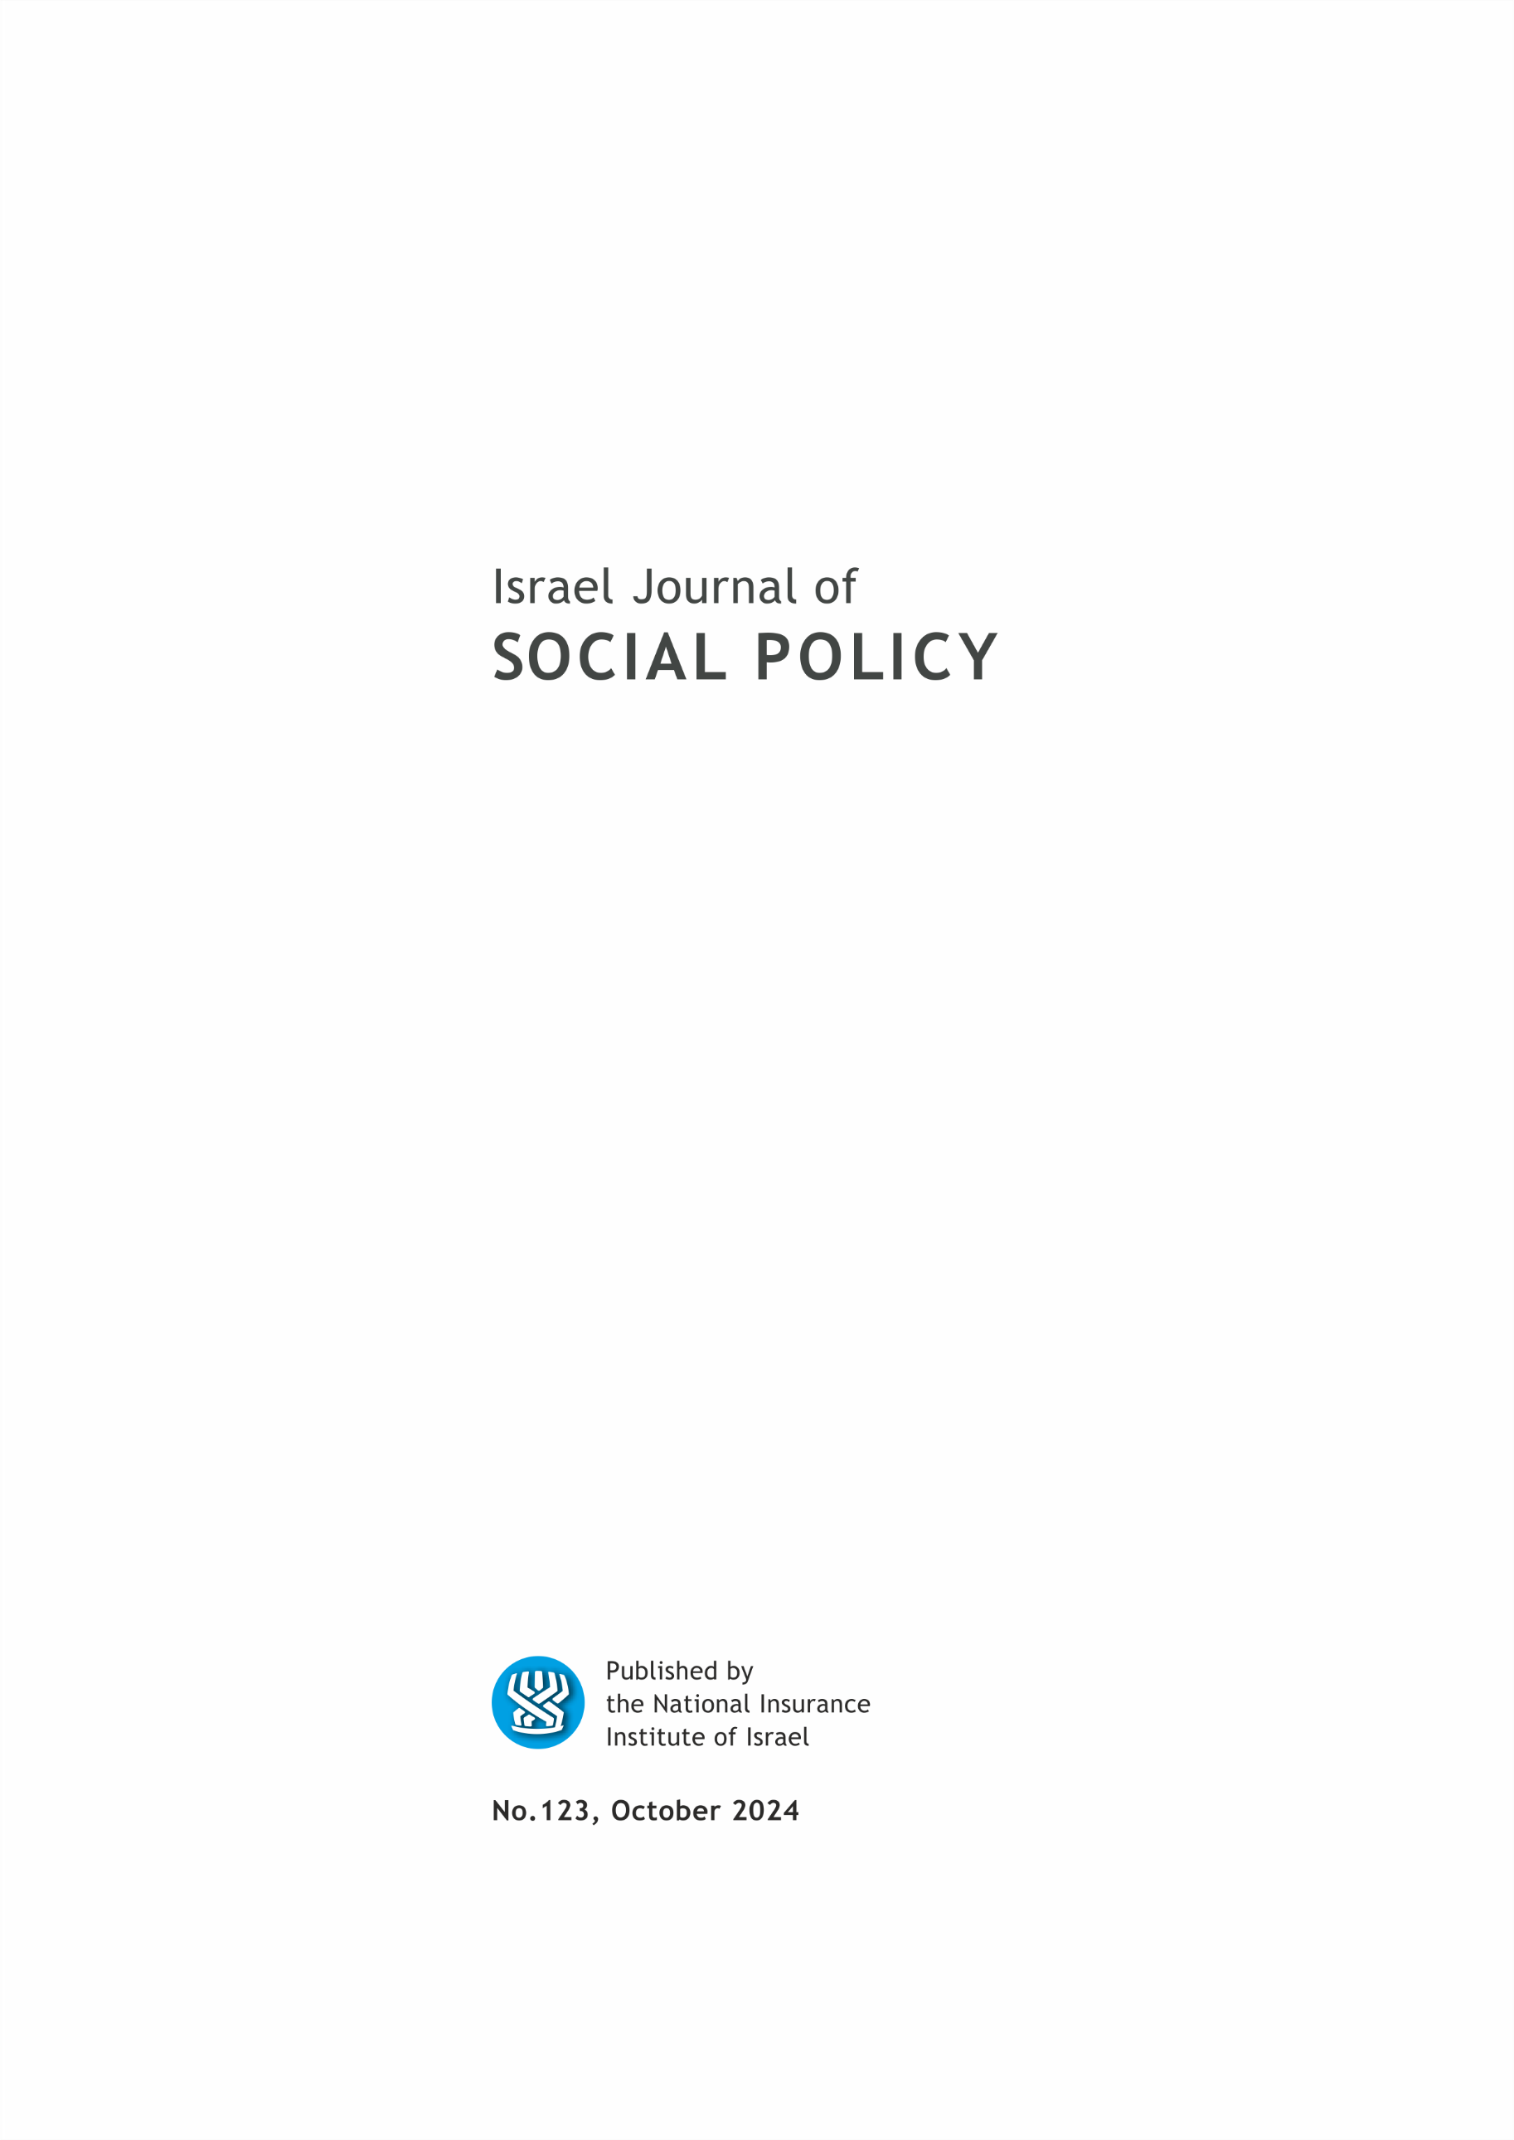

EDITORIAL BOARD

Israel (Issi) Doron, Editor in chief
Nitsa (Kaliner) Kasir, Chairman
Suliman Abu Bader
Leah Achdut
Jon Anson
Liat Ayalon
Orly Benjamin
Nissim Cohen
Sylvie Fogiel-Bijaoui
John Gal
Jochanan Stessman
Aviad Tur-Sinai

Managing Editor: Maya Orev-Attal
Typesetting: Onit Computer Services Ltd.

Contents
Expanding the range of bereavement interventions following Israel’s “Black Sabbath” events and the “Iron Swords” war: Toward an ecological perspective – Opinion article
Orit Nuttman-Shwartz and Rachel Dekel
Negotiating from the margins: Social work with people in poverty in Arab-Palestinian society in Israel
Ensherah Khoury , Michal Krumer-Nevo and Limor Lotan
The one who sees without being seen: The manpower crisis from the standpoint of staff members in community psychiatric rehabilitation
Taisia Leikin , Max Lachman and Ayala Friedlander
“Pension avoidance”: Factors leading to the lack of pension-related information among the Israeli population in all of its diversity
Guy Hochman , Rami Yosef , Shenhavm Malul and Tehila Kalagy
Grandmothers, mothers and infant morbidity: First births among the Arab population in Israel
Nuha Sliman , Jon Anson , Julie Cwikel and Ofra Anson

Summaries of the main articles

Expanding the range of bereavement interventions following Israel’s “Black Sabbath” events and the “Iron Swords” war: Toward an ecological perspective – Opinion article
Orit Nuttman-Shwartz and Rachel Dekel

In this opinion article we review Israel’s intervention policy and variety of services provided to bereaved families and advocate for their expansion, especially in light of the October 7th (“Black Sabbath”) events and the consequent “Iron Swords” war.
A review of the theoretical literature and the existing laws for the treatment of bereaved families reveals that the common conception for understanding loss and caring for the bereaved is an individualized one and rests on the premise that each individual responds differently to loss and grief; the model of “enduring connections” between the bereaved and the other(s) is thus seen as a personal process. Accordingly, the review shows that most of the interventions provided to bereaved families in Israel are individual, whereas group interventions – that were customary in the past – gradually decreased. On the other hand, a review of global literature suggests a range of possibilities that include both family and community resources.
As such, we suggest that there is room to expand the range of interventions that are provided in Israel and to develop these interventions on a broad ecological basis, taking into consideration the individual, the family, the community, and society. This perspective will allow bereaved individuals and aid workers to select, adapt, and combine a pool of individual, family, group and community services. Ecological considerations are especially important when dealing with numerous and collective events of bereavement and loss such as those that Israeli society is facing these days.

Negotiating from the margins: Social work with people in poverty in Arab-Palestinian society in Israel
Ensherah Khoury, Michal Krumer-Nevo³ and Limor Lotan³

This article examines the challenges social workers in the Israeli Arab-Palestinian society face and the practices they employ, distinguishing between common challenges in social work with individuals experiencing poverty in Israel and those distinctive to the Arab-Palestinian communities. Applying a critical cultural sensitivity perspective, we consider poverty's broad social, political, and economic contexts.
Our findings are based on a thematic analysis of 51 semi-structured interviews with social workers in five welfare departments of Arab and Jewish-Arab locales. Our findings indicate that social workers with Arab-Palestinian service users share some challenges with all Israeli social workers in addressing material needs and empathetically understanding the seemingly maladaptive behavior of service users. Social workers also face challenges unique to Arab-Palestinian society, shaped by social, political, and cultural contexts: insufficient employment opportunities, insufficient appropriate welfare services, and difficulties assisting people without status and rights. Although our interviewees are Arab-Palestinians, they tend to feel culturally alien from their service users, particularly regarding patriarchal conduct. In response to the overall challenges, they employ a culturally sensitive approach while constantly bargaining with patriarchal norms. We conclude that a notable improvement in the Arab-Palestinian society situation necessitates structural reforms. Meanwhile, social workers could benefit from heightened awareness regarding the impact of structural and social contexts on their service users.

The one who sees without being seen: The manpower crisis from the standpoint of staff members in community psychiatric rehabilitation
Taisia Leikin, Max Lachman and Ayala Friedlander⁵

The Community Rehabilitation of Persons with Mental Health Disability Law (2000) has led to the extensive development of community rehabilitation services, accompanied by an influx of professional and para-professional workforce into the growing circle of service providers. Nevertheless, over the years, the rehabilitation system has been struggling with difficulties in establishing professional and organizational processes required to strengthen and develop human capital in the field (Aviram, Lachman, & Ifergan, 2023). These difficulties have resulted in a current workforce crisis in the rehabilitation system, manifesting in an inability to provide services adequately, a shortage of workers, recruitment difficulties, and high turnover rates.
A survey conducted by the ISPRA among 552 rehabilitation field workers in varied roles and service-domains, examined their perspectives on rehabilitation work and their evaluation of workforce issues. Quantitative and qualitative data were collected and analyzed, presenting a complex picture with differences between role types and positions in workers’ perceptions regarding workforce issues.
Findings show altruistic motives among rehabilitation staff workers, along with their encounter with substantial barriers in the occupational reality. The survey reveals salient gaps between efforts being invested by workers, and the erosion of their sense-of-value and perceived work-related gain and reward.
These findings should be addressed with a practical approach to support a functioning and developing psychiatric rehabilitation system. We suggest several steps to be taken in order to address the current human resource crisis and reduce the presented gaps.

“Pension avoidance”: Factors leading to the lack of pension-related information among the Israeli population in all of its diversity
Guy Hochman, Rami Yosef, Shenhavm Malul and Tehila Kalagy

Despite the fact that pension savings are people’s main source of income in their retirement years, consumers’ awareness and knowledge about pension savings is quite weak. Many people do not acquire the relevant knowledge to plan for their future retirement. This behavior is worrying, since the pension systems transfer the risks and responsibilities to the individual.
The non-acquisition of knowledge is a hidden phenomenon, in that it is not an action, but rather the lack of action. For this reason, there have been few studies of this phenomenon and fewer (if any) studies have examined this phenomenon among conservative populations. Accordingly, this study aimed to evaluate participants’ non-acquisition of pension-related information, their motives for the non-acquisition of that information, and their levels of pension-related literacy. This included the comparison of two conservative populations that have low levels of exposure to such knowledge (i.e., the Ultra-Orthodox and Arab populations) with the general Israeli population.
A qualitative methodology was used to characterize the non-acquisition of pension-related knowledge and the reasons for it, from the perspective of the individual. The study’s findings reveal similar levels of non-acquisition of pension-related knowledge among the different populations. However, surprisingly, the reasons for not acquiring this knowledge differed between the populations. Members of the general population purposefully avoided acquiring pension-related knowledge due to concerns that pension funds were being improperly managed and concerns about making incorrect decisions. In contrast, the Ultra-Orthodox and Arab individuals’ non-acquisition of pension-related knowledge stemmed from a lack of access to pension-related information and a lack of knowledge as to where relevant information could be found. These research findings may help policymakers to take culturally appropriate steps to deal with the non-acquisition of pension-related knowledge and to increase pension savings.

Grandmothers, mothers and infant morbidity: First births among the Arab population in Israel
Nuha Sliman, Jon Anson, Julie Cwikel and Ofra Anson¹¹

The evolutionary perspective argues that if women survive beyond their reproductive life span, this is because they contribute to human fitness and survival through their contribution to the survival and growth of their grandchildren, in particular their daughter’s children. We investigate an extension of this argument, namely, that even under conditions of low mortality, a close relation between a mother and her mother, or even her mother-in-law, will reduce infant morbidity and hospitalization. We interviewed 388 Palestinian-Arab mothers who gave birth at the French Hospital in Nazareth, one year after their first birth, and recorded their infants’ diseases in the past month, and hospitalization in the past year.
Our results indicated: (1) Mothers of children who were not sick in the past month, and not hospitalized in the past year, had significantly better relations with their mothers and mother-in-law than mothers of children who were sick or hospitalized. (2) Multivariate analysis indicated that illness was lower for children whose maternal grandmothers were still alive; who breastfed for six months or longer and whose mothers had high school matriculation or higher education. Hospitalizations were fewer among children who had breastfed for six months or longer; whose pregnancy had not been designated at risk and whose mothers were non-religious.
We conclude that even in today’s conditions, with accessible medical services and growing education for women, the presence of the maternal grandmother can significantly reduce infant morbidity.

School of Social Work, Sapir Academic College
School of Social Work, Bar-Ilan University
Spitzer Department of Social Work, Ben-Gurion University of the Negev
Findings from a survey among mental health rehabilitation staff members during 2022
Israel Psychiatric Rehabilitation Association (ISPRA)
Faculty of Social Welfare and Heath Sciences, University of Haifa
Baruch Ivcher School of Psychology, Reichman University
Department of Business Administration, Ben-Gurion University of the Negev
Faculty of Business Administration, Ono Academic College
Department of Public Policy and Management, Ben-Gurion University of the Negev
Spitzer Department of Social Work, Ben-Gurion University of the Negev
Faculty of Health Sciences, Ben-Gurion University of the Negev
Center for Women’s Health Studies and Promotion, Ben-Gurion University of the Negev

