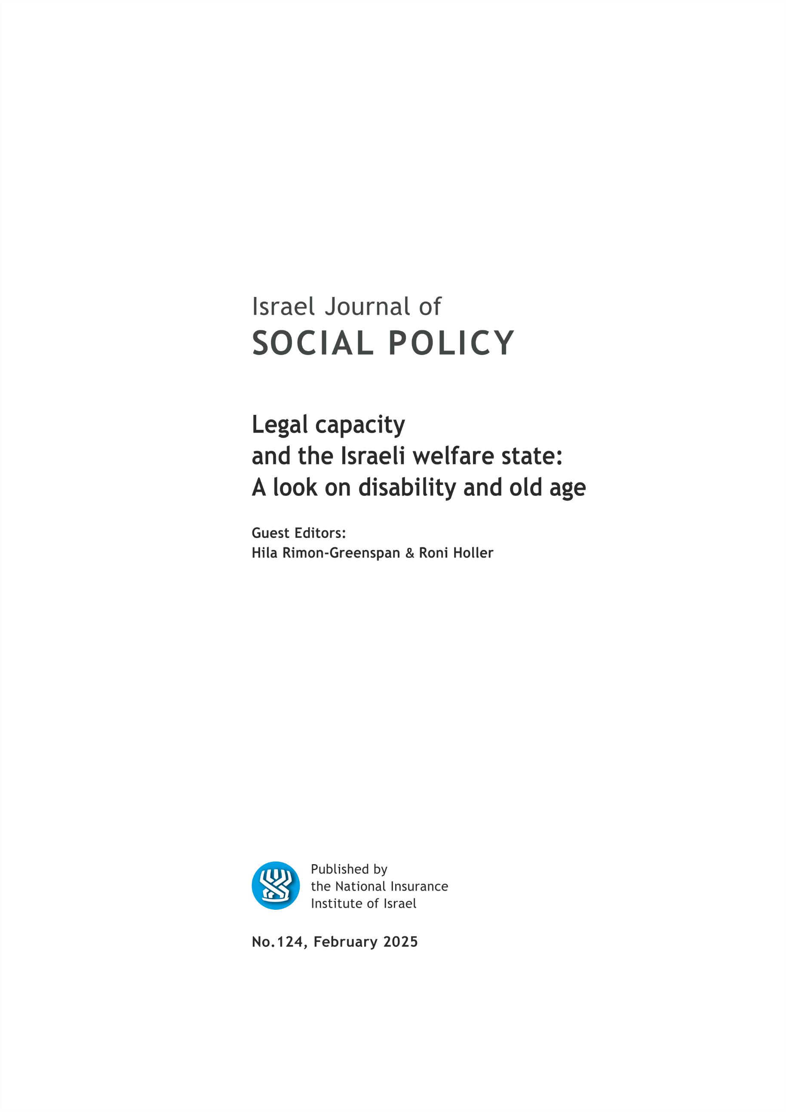

EDITORIAL BOARD

Israel (Issi) Doron, Editor in chief
Nitsa (Kaliner) Kasir, Chairman
Suliman Abu Bader
Leah Achdut
Jon Anson
Liat Ayalon
Orly Benjamin
Nissim Cohen
Sylvie Fogiel-Bijaoui
John Gal
Jochanan Stessman
Aviad Tur-Sinai

Managing Editor: Maya Orev-Attal
Typesetting: Onit Computer Services Ltd.

Contents
Durable power of attorney for older adults: Examining the implementation of Amendment 18 to the Legal Capacity and Guardianship Law
Ile Kermel-Schiffman and Shirli Resnizky
"Who shall I appoint if not my children?" Aspects of choosing a proxy while executing a durable power of attorney by older adults
Malka Doron
Social workers’ perceptions and considerations in legal capacity appointments for people with disabilities: recommendations for training and policy
Roni Holler and Shirly Werner
How do we design a legal capacity policy, legislation, and tribunal?
Using the approach of disability-rights-based dispute system design
Roni Rothler
Guardianship and self-determination: a qualitative study among people with cognitive disabilities and their guardians
Dori Rivkin
From legislation to implementation of supported decision-making in Israel from a policymakers’ viewpoint
Ornit Dan and Keren Orbach Barnea
"You're really experiencing something that's not classic volunteering": Motivations for volunteering, challenges, and dilemmas of volunteering decision-making supporters.
Rachel Levy-Araki, Itay Greenspan, Roni Holler and Shirli Werner
Supported decision-making best practice – conceptualization from the field
Hila Rimon-Greenspan
Choosing support and supporting choice: On the connection between supported decision-making, developing autonomy and computer games worth NIS 5,000
Iris Schneid and Peter Malmquist

Summaries of the main articles

Durable power of attorney for older adults: Examining the implementation of Amendment 18 to the Legal Capacity and Guardianship Law
Ile Kermel-Schiffman and Shirli Resnizky

In 2016, Amendment 18 to Israel's Legal Capacity and Guardianship Law of 1962 was enacted to establish an alternative legal tool to traditional guardianship. The amendment introduced a "durable power of attorney" (DPA) document, which enables individuals, while still capable, to appoint another person to make medical, financial, and personal decisions on their behalf should they be incapacitated in the future due to medical or cognitive decline. This study aims to assess the implementation of Amendment 18 and the process of drafting the DPA document. The study utilized administrative data analysis of appointors and proxies, supplemented by an online survey of attorneys who had completed the training necessary to draft DPAs. Findings from the administrative data suggest that the DPA tool is currently used primarily by older adults, though adoption rates remain low. Additionally, usage appears to be concentrated in central regions of the country and among individuals of medium-to-high socioeconomic status. Survey responses from attorneys highlighted the cost of preparing the document as a barrier to broader adoption. The majority of attorneys reported limited experience with the DPA tool but expressed a desire for more comprehensive training. Based on these findings, it is recommended to promote broader distribution of the DPA to increase its accessibility and to explore mechanisms that facilitate use among lower- and middle-income populations. The study further underscores the critical role attorneys play in implementing DPAs. Given that the process involves navigating complex personal and family dynamics, specialized training on these issues is recommended to equip attorneys with the skills needed to support clients effectively.

"Who shall I appoint if not my children?" Aspects of choosing a proxy while executing a durable power of attorney by older adults
Malka Doron

The durable power of attorney is a new legal planning tool in Israel designed to prepare a person for the possibility of deteriorating abilities and functions. It enables a person (the principal) to designate a surrogate decision-maker who will act on their behalf on personal, financial, and healthcare issues in the event of future incapacity and to provide the future proxy with preliminary instructions for how to act in each area. One of the most important considerations when executing a durable power of attorney is choosing the future proxy, who will carry out the principal’s wishes once the durable power of attorney becomes effective. Despite its importance, this aspect has received relatively little attention in research. Based on qualitative-phenomenological research exploring the experience and meaning of executing a durable power of attorney by senior citizens, this article presents and discusses findings regarding the aspect of selecting and appointing a future proxy. A total of 16 in-depth interviews were conducted with senior citizens who executed a durable power of attorney. Findings indicate two main themes when choosing a proxy: (1) Appointing family members; and (2) General considerations in suitability for the role. The findings suggest that older adults choose a proxy while executing a durable power of attorney, in the same ways they seek other forms of support and assistance. Thus, and in line with The Hierarchical Compensatory Model, interviewees preferred to designate family members (mainly close family) as future proxies. Nonetheless, considerations concerning suitability for the role were part of the process, and the Task-Specific Model can provide further insight into these aspects. Possible implementations point to the meaningful role of lawyers involved in executing a durable power of attorney in old age, particularly regarding selecting a proxy, to enhance the tool’s potential to promote emotional and psychological well-being in old age.

Social workers’ perceptions and considerations in legal capacity appointments for people with disabilities: recommendations for training and policy
Roni Holler and Shirly Werner⁴

In 2016, a significant reform of Israel's Legal Capacity and Guardianship Law (1962) was enacted, known as Amendment 18. This reform seeks to minimize the use of guardianship and promote less restrictive alternatives, such as supported decision-making. Given the central role of social workers in the legal capacity domain, we conducted a series of studies to explore the perceptions and considerations of social workers who work in the field of disability. In this article, we take an integrative and broad perspective to discuss the implications of our findings. Specifically, we examine the dual goals social workers attribute to guardianship – preventing risks and enhancing quality of life – and the factors they consider when making recommendations, including the client’s diagnosis, functional level, and personal wishes. Our discussion focuses on the significant gap between the vision of Amendment 18 and the actual perceptions and practices of social workers. Based on our findings, we propose several recommendations for training and policy reform, aimed at fostering the comprehensive implementation of Amendment 18. These changes would better enable individuals with disabilities to fully exercise their right to legal capacity.

How do we design a legal capacity policy, legislation, and tribunal?
Using the approach of disability-rights-based dispute system design
Roni Rothler

The right to legal capacity within human rights not only signifies the status of being a legal entity but also encompasses the authority to actively engage in various undertakings, transactions, and determinations that pertain to one's existence. Furthermore, it embeds the essential prerogative to receive assistance when navigating the decision-making landscape. However, despite this overarching principle, legal capacity can be restricted under certain circumstances, primarily when there is a perceived incapacity in decision-making. This often leads to the imposition of alternative decision-making mechanisms as a protective measure to safeguard the individual's well-being. These legal capacity proceedings typically center around older adults and individuals with cognitive or intellectual disabilities, a phenomenon eloquently termed as "civil death" by scholars championing the cause of disability rights. The restriction of legal capacity raises poignant concerns, particularly regarding its potential ramifications on people’s access to justice.
These concerns have acted as catalysts for both international and national policy and legislative reforms, placing a heightened emphasis on upholding the right to legal capacity. Article 12 of the Convention on the Rights of Persons with Disabilities (“CRPD”) and Amendment 18 to the Israeli Legal Capacity and Guardianship Law manifest these reforms. The primary vehicle through which this emphasis is channeled is the framework of supported decision-making and the focus on the person’s will and preferences instead of their “best interest”.
Yet, even with these commendable efforts, debates persist, creating a crucible of discussion around the optimal design of legal capacity policies, legislation, and tribunals. The crux of this discourse revolves around striking a delicate balance between the autonomy-focused paradigm and the tools required to harmonize the respect for individuals' will and preferences with the imperative to shield them from potential harm. This ongoing debate underscores the inherent challenges in adapting traditional legal systems to embrace the evolving social norms.
In response to these persistent debates, this article proposes a novel approach that addresses the foundational principles of legal capacity and the critiques surrounding supported decision-making. The strategy intertwines theoretical constructs with pragmatic considerations, weaving a comprehensive narrative through integrating disability rights and dispute system design (DSD).
A proposed solution emerges as a "disability-rights-based dispute system design," envisaged as a guiding framework in the evolution of legal capacity frameworks. This innovative design advocates a fundamental revision of the pillars and conventions underpinning legal capacity frameworks, replacing them with a structure firmly rooted in the principles of disability rights. This is done by providing a “legal capacity” and “disability rights” interpretation to DSD’s six elements: goals, stakeholders, context and culture, process and structure, resources, and successfulness, accountability and learning.
By narrowing the gap between the ideals of legal capacity and their tangible realization, the focus shifts to creating dispute and pre-dispute mechanisms that not only respect but actively enhance legal capacity. Consequently, the disability-rights-based DSD stands as a promising approach to effectively navigate legal capacity issues and fortify the channels leading to justice for people with disabilities and older adults.

Guardianship and self-determination: a qualitative study among people with cognitive disabilities and their guardians
Dori Rivkin

Introduction: Guardianship is a legal arrangement designed to protect people with disabilities who are unable to take care of their affairs on their own. The court appoints a guardian, usually a parent, who is responsible for the person's safety and well-being and is authorized to make decisions for them. This study aimed to examine the experiences of people whose designated guardians are family members and their guardians. It addressed the questions of how each party perceives the guardianship arrangement; how decisions are made under such arrangement, and to what extent do people under guardianship experienced self-determination, i.e. as having the desired control over their life?
Method: Semi-structured interviews were conducted with 13 pairs of people with disabilities and their guardians. Nine of the designated guardians were parents of those under guardianship, two were siblings, one was a daughter and another a family friend. Among the people with disabilities there were nine men and four women, all but one were 30-50 years old. All have cognitive disabilities: eight have a diagnosis of IDD, two of ASD and two have head injuries which occurred in childhood.
Findings: Most guardians see the appointment as a routine procedure, and few question its necessity or object to its infringement on the autonomy of the person under guardianship. Parents see being appointed as guardian of their adult children with disabilities as a natural continuation of their role from their son or daughter's childhood. Most people for whom guardians were appointed are content to have a family member responsible for them. Although the guardian has the authority to decide alone, rarely does the person guardianship not have any influence. Several guardians reported realizing that imposing their authority on their charge was not feasible or inappropriate. Although both sides accept the guardian's authority, in practice decisions are usually negotiated using various direct and indirect tactics.
Regarding self-determination, some of the people with disabilities experience the guardian as supported and enabling self-determination, while others see the guardian as limiting their autonomy, especially regarding the control over their money. For some people with designated guardians, making choices and realizing their individual wishes is less important than family harmony and belonging.
Discussion: It is evident that the family members, both guardians and people with disabilities for whom guardian is appointed are not familiar and do not identify with the objections to guardianship, which led to the Amendment of the Legal Capacity and Guardianship Law in Israel. Changing the guardianship system will require multi-systemic efforts. Further research is proposed to deal with the relationship between guardianship and family kinship. Other relevant research areas include comparing guardianship and "supported decision-making". There is also need for research among populations that were not included in the current study, and especially people who are non-verbal, people with psychiatric disabilities, elderly people with dementia whose children serve as their guardians, as well as populations in Israel that are underrepresented in this study, such as ultra-Orthodox Jews and Arabs.

From legislation to implementation of supported decision-making in Israel from a policymakers’ viewpoint
Ornit Dan and Keren Orbach Barnea⁷

Supported decision-making is a legal arrangement that was established as part of Amendment 18 to the Legal Capacity and Guardianship Law in 2016 (hereinafter: the Law). The Legal amendment posed a serious challenge for the State: establishing a new legal tool. The road to implementing the legislation was characterized with parallel processes of policy making along with intense field work. This, due to taking advantage of opportunities and available resources.
The implementation of the Law was based on learning form the experience that was established in Israel prior to the legislation: about 40 legal appointments of decision-making supporters issued by the court, pilot programs that were initiated by social organizations, and more, alongside an international review of applied experience in the field. The Administrator General's main mission at the beginning was to monitor the process and to bring together relevant government offices, other official bodies and civil society organizations. For that purpose, a few steering committees were established with a different focus for each of them.
The main challenge was to raise awareness of the new legal procedure among different groups. At the same time, new guidelines were established and issued based on the field experience, and for all relevant parties to proceed similarly until further regulations are published. The need that rose from the field for training of decision-making supporters and the need to establish a professional doctrine led to the establishment of professional training courses, along with developing the practice which was based on bottom-up knowledge from the field with top-down policy of the Administrator General.
Our goal is to expand the number of legal appointments in large numbers. For this purpose, we must acknowledge the barriers and face the challenges with courage and professionalism. Currently we are focusing on developing the 'appointment by agreement' option and developing a unique supervision model for supported decision-making, which may bring us closer to this goal.

"You're really experiencing something that's not classic volunteering": Motivations for volunteering, challenges, and dilemmas of volunteering decision-making supporters.
Rachel Levy-Araki, Itay Greenspan⁸, Roni Holler⁸ and Shirli Werner⁸

Supported decision-making (SDM) is a recently developed policy alternative to disparaged guardianship schemes. SDM aims to provide individuals with disabilities or the elderly support in the decision-making process. Since 2016, SDM has been formalized in Israel. One unique and understudied attribute of the Israeli SDM scheme is the optional appointment of volunteer decision-making supporters. Given the distinct nature of this role, the present study aims to explore the motivations behind volunteering, as well as the key dilemmas and challenges that volunteers face while fulfilling their support duties. To achieve this goal, open-ended interviews were conducted with volunteer supporters for people with disabilities. The research findings reveal that the volunteers are motivated by both universal (e.g., seeking a meaningful and challenging activity) and role-specific motivations, such as a desire to promote an ideologically pioneering social service. In addition, the study identifies the challenges and dilemmas that the volunteers have encountered, such as the need to build trust and close relationships with those they support and to manage tensions between two competing logics: the person’s own wishes vis-a-vis the volunteer’s perceived conceptions of safeguarding the person’s best interests. As the SDM schemes continue to evolve, insights from this research will help to refine recruitment, training, and mentoring procedures tailored to volunteer supporters in SDM.

Supported decision-making best practice – conceptualization from the field
Hila Rimon-Greenspan

Amendment no. 18 to the Capacity and Guardianship Law, 5722-1962, which passed in 2016, recognized and established the new legal tool of supported decision-making (SDM) as an alternative to guardianship. SDM is a new practice, not only in Israel, but also globally, and the empirical research in the field is scarce. Supported decision making is an official appointment in which the decision-making supporter is appointed by the court. The role of the supporter is to preserve the autonomy of a person (who can be an old person or a person with disabilities) who find it difficult to make decisions or to understand information pertaining to their affairs. The supporter assists the person in their financial, personal or medical affairs, by: collecting all the needed information for making a decision in a certain matter and by making that information accessible and understood by the decision maker; by assisting in all stages of making a decision and subsequent decisions patriating to that matter; and by assisting the decision maker in exercising their rights and the services they are entitled to. The decision-making supporter can be a relative (i.e., a family member), a paid professional supporter, or a volunteer supporter.
Little is known about the implementation of SDM arrangements globally and in Israel, and there is no established model for best practice in SDM. Therefore, the goal of this research was to examine the viewpoints of decision makers, decision making supporters, and professionals on what is best practice in SDM and its components. This, by conducting interviews with decision makers, their decision-making supporters, and a third person who is closely familiar with their SDM arrangement. The findings of this research suggest that there are five components to best practice in SDM: support that is beneficial for the person; the supporter’s commitment to the decision-maker’s autonomy and right to make their own decisions; the nature and quality of the decision maker and the supporter's relationship; the praxis of support; and fundamental and ethical dilemmas in the practice of support and the supporter’s ethical conduct.
The research findings and conclusions, along with the suggested conceptualization of best practice in SDM, may contribute to training, practice, and policy in the field of SDM in Israel and its advancement.

Choosing support and supporting choice: On the connection between supported decision-making, developing autonomy and computer games worth NIS 5,000
Iris Schneid and Peter Malmquist

This opinion article examines the Supported Decision-Making (SDM) process for autistic individuals, in the context of Amendment 18 to Israel’s Legal Capacity and Guardianship Law. The authors – a mother and son, both autistic – combine theoretical analysis with insights from their personal experience. They present the support mechanism as a practical alternative for developing autonomy and self-agency, while preserving individual rights to experiment, learn from mistakes, accommodate their needs, and develop independently.
The article, structured around a dialogue between the authors, presents supported decision-making as a more suitable and appropriate alternative to the traditional guardianship model. It addresses social barriers that challenge the competency and rights of people with disabilities. Drawing on disability studies theories, the article reveals how prevalent social attitudes discriminate against and limit autistic individuals' ability to realize their autonomy.

Department of Health Systems Management, School of Health Sciences, Ariel University, Aging Team, Myers-JDC-Brookdale Institute
Aging Team, Myers-JDC-Brookdale Institute
Department of Gerontology, Faculty of Welfare and Health Sciences, University of Haifa
School of Social Work and Social Welfare, Hebrew University of Jerusalem
Equality, Diversity & Community Commission, Tel-Aviv University
Myers-JDC-Brookdale Institute
Administrator General, Ministry of Justice
Alyn Hospital and the School of Social Work and Social Welfare, Hebrew University of Jerusalem
Myers-JDC-Brookdale Institute and Paul Baerwald School of Social Work and Social Welfare, Hebrew University of Jerusalem
Autist, Department of Sociology and Anthropology, Ben-Gurion University of the Negev
Autist

